Deploying 3 -Tier application
Created task manager app and deployed it locally.
Sample:
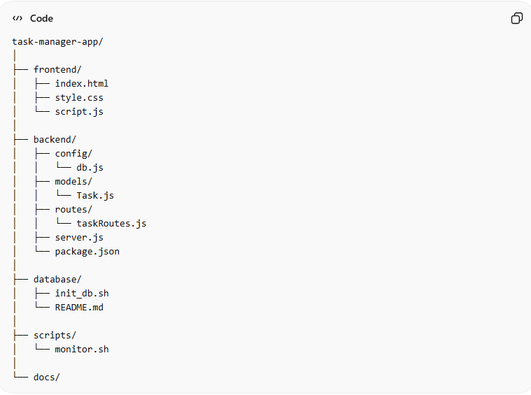
Create Project Structure:
tree -L 2 -I "node_modules"
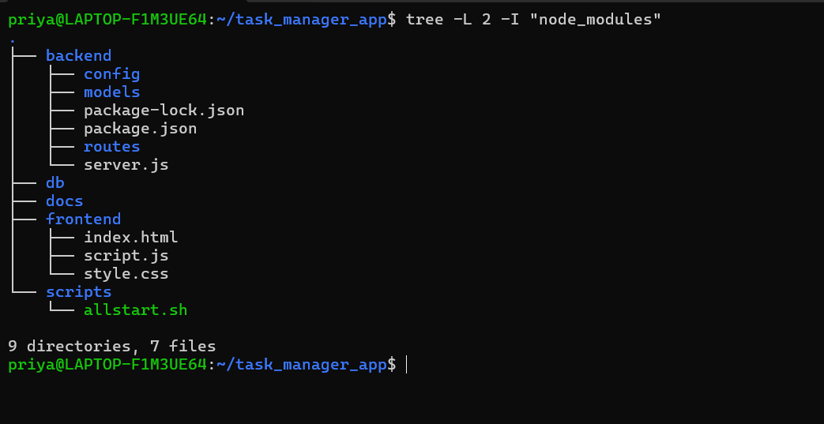

mkdir task-manager-app
cd task-manager-app
mkdir frontend backend database scripts docs

Frontend UI Layer
BackendApplication Logic Layer
DB Database layer .It stores and retrieves data. In my case, I have db details in backend directory itself.
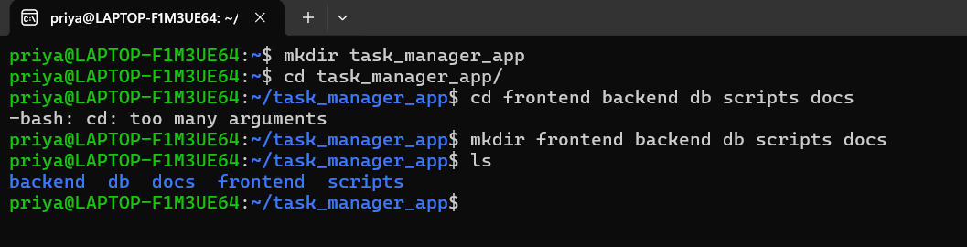

Backend Setup Folder structure:
cd backend
npm init -y
npm install express mongoose cors
mkdir config models routes
touch server.js config/db.js models/Task.js routes/taskRoutes.js
cd ..

Note: Every Node.js project must have a package.json
Express.js Build backend APIs.
Mongoose Connect Node.js to MongoDB.

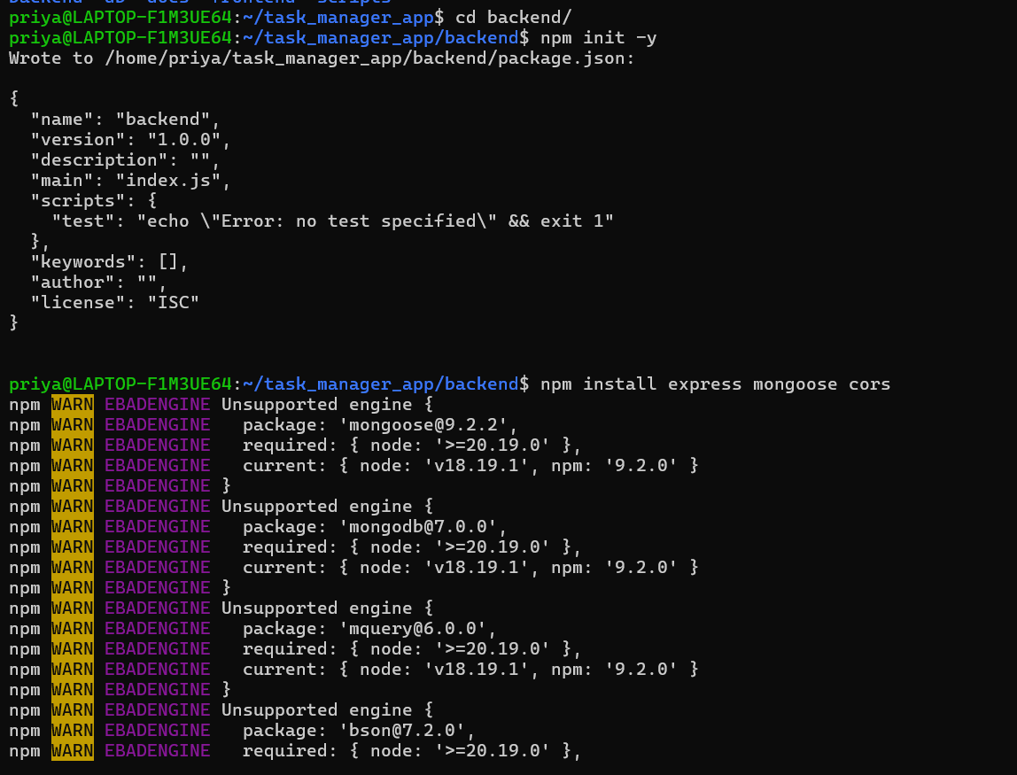
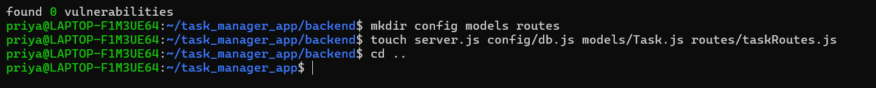

Frontend Folder structure:
cd frontend
touch index.html script.js style.css
cd ..
DB Setup:
Install MongoDB
mongod –version
if not installed we need to use below command
sudo apt update
sudo apt install mongod
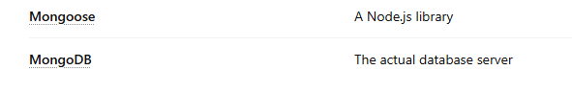
Note: Your Node app needs an actual database server running to store data.
Without it → backend cannot connect.

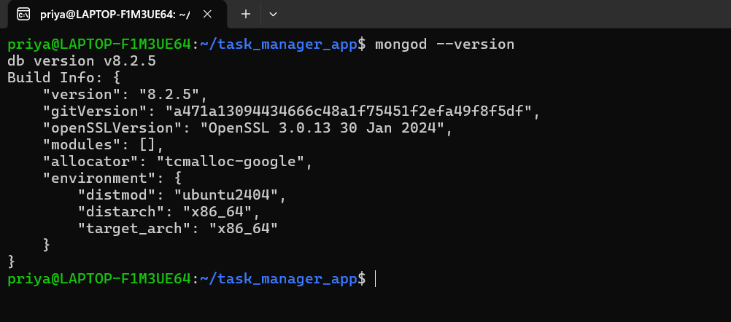
Started the mongod service and verified it:
sudo service mongod start
pgrep mongod
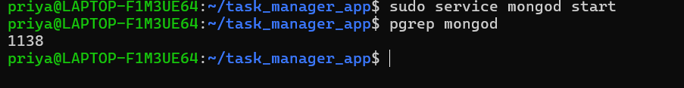
If you see a PID → DB running. In our case, our PID is 1138. So, DB is running successfully.
We are done with DB setup.
Backend Code Setup
backend/config/db.js
const mongoose = require('mongoose');
const connectDB = async () => {
try {
await mongoose.connect('mongodb://127.0.0.1:27017/taskdb');
console.log('MongoDB Connected');
} catch (error) {
console.error(error);
process.exit(1);
}
};
module.exports = connectDB;

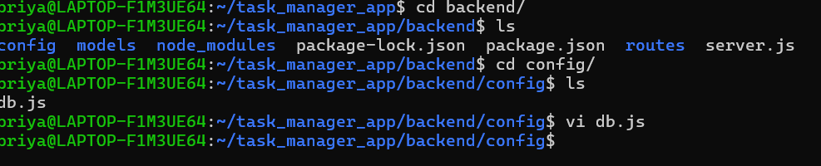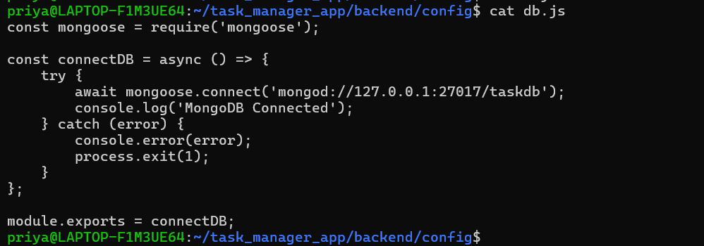

backend/models/Task.js
const mongoose = require('mongoose');
const TaskSchema = new mongoose.Schema({
title: { type: String, required: true }
});
module.exports = mongoose.model('Task', TaskSchema);

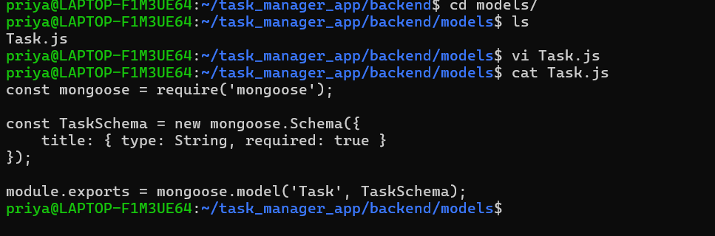

backend/routes/taskRoutes.js

const express = require('express');
const router = express.Router();
const Task = require('../models/Task');
router.get('/', async (req, res) => {
const tasks = await Task.find();
res.json(tasks);
});
router.post('/', async (req, res) => {
const task = new Task({ title: req.body.title });
await task.save();
res.json(task);
});
module.exports = router;
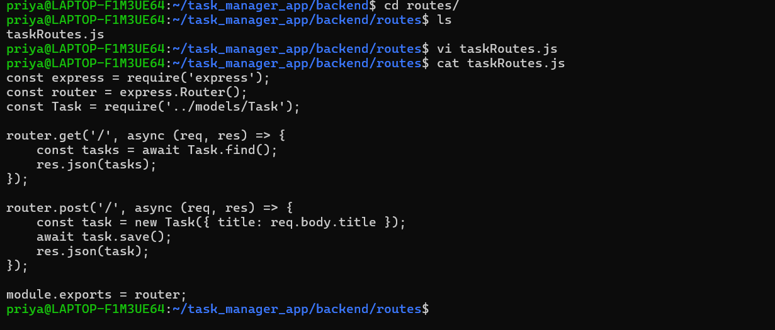
backend/server.js
const express = require('express');
const cors = require('cors');
const connectDB = require('./config/db');
const app = express();
connectDB();
app.use(cors());
app.use(express.json());
app.use('/tasks', require('./routes/taskRoutes'));
app.listen(5000, () => {
console.log('Server running on port 5000');
});
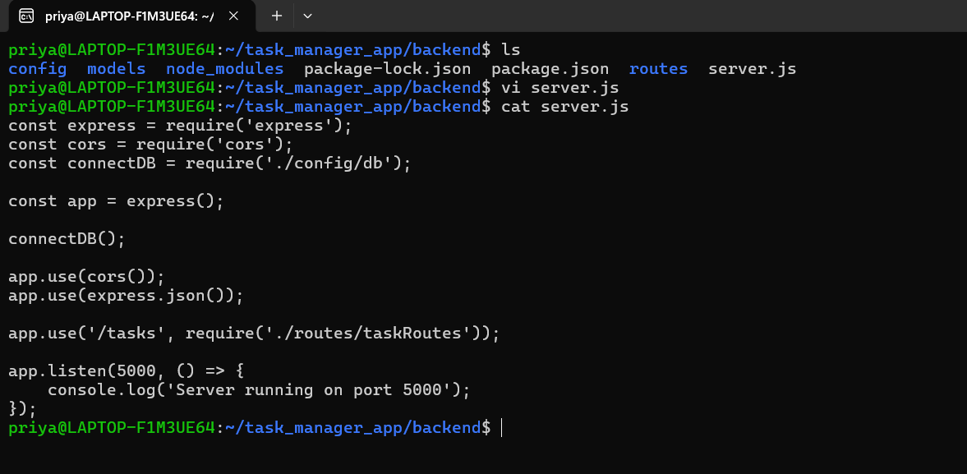
Frontend Code Setup
frontend/index.html
<!DOCTYPE html>
<html>
<head>
<title>Task Manager</title>
</head>
<body>
<h1>Task Manager</h1>
<input type="text" id="taskInput">
<button onclick="addTask()">Add Task</button>
<ul id="taskList"></ul>
<script src="script.js"></script>
</body>
</html>

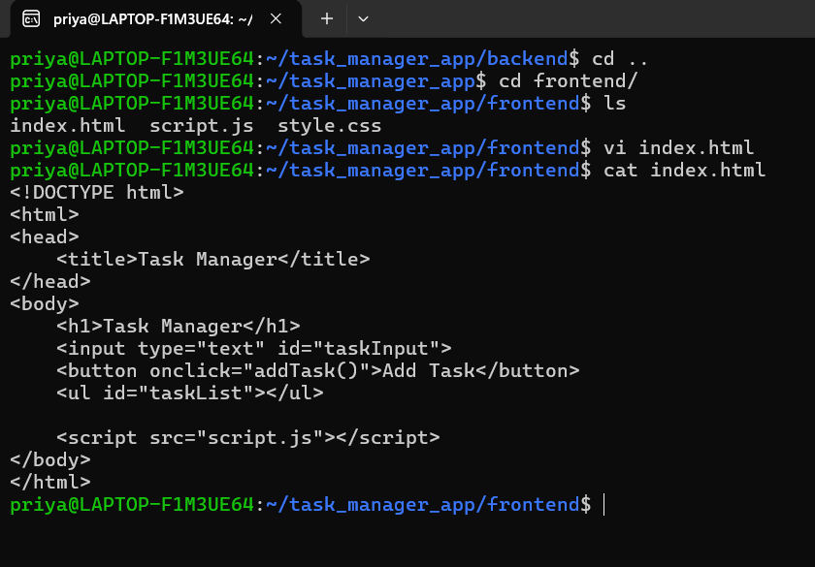
frontend/script.js
async function loadTasks() {
const res = await fetch('http://localhost:5000/tasks');
const tasks = await res.json();
const list = document.getElementById('taskList');
list.innerHTML = '';
tasks.forEach(task => {
const li = document.createElement('li');
li.textContent = task.title;
list.appendChild(li);
});
}
async function addTask() {
const input = document.getElementById('taskInput');
await fetch('http://localhost:5000/tasks', {
method: 'POST',
headers: { 'Content-Type': 'application/json' },
body: JSON.stringify({ title: input.value })
});
input.value = '';
loadTasks();
}
loadTasks();

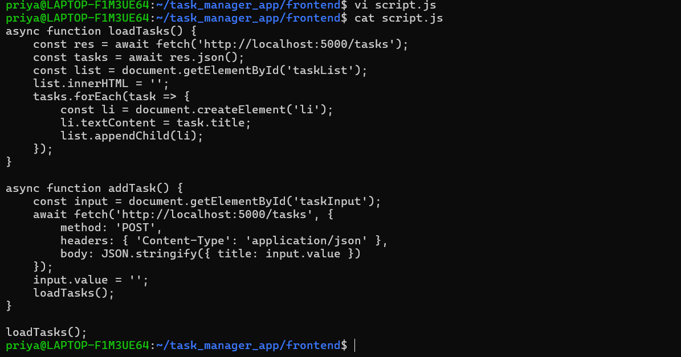

Run Application:

Starting and verifying mongodb:

Sudo service mongod start
Pgrep mongod

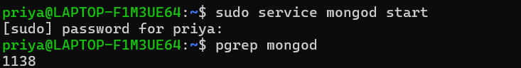

Starting Backend:
cd backend
node server.js
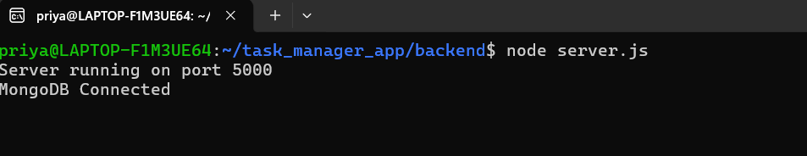
You should keep backend run

Testing API connection:
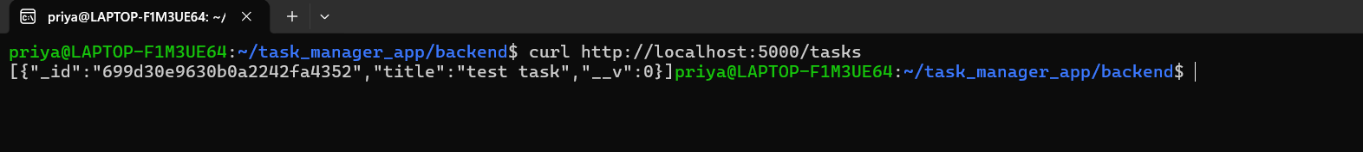

Testing Frontend:
Open windows file explorer double click on index.html. it will open the chrome.
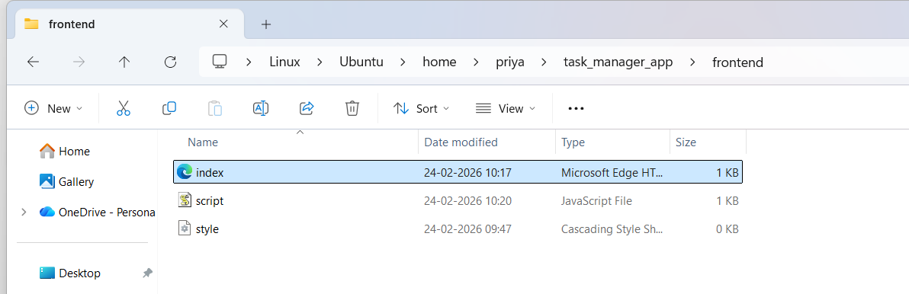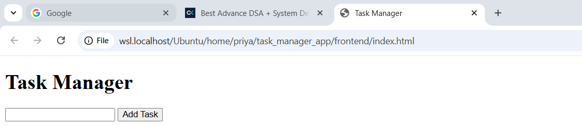

Writing scripts to start the service ,check whether the services are running or not instead of manually checking it.

#!/bin/bash
echo "Starting MongoDB..."
sudo service mongod start
sleep 3
echo "Starting Backend..."
cd ../backend || exit
npm start &
sleep 5
echo "Starting Frontend..."
cd ../frontend || exit
npx serve . &
sleep 5
echo "Opening Application..."
xdg-open http://localhost:3000 &
echo "All services started."

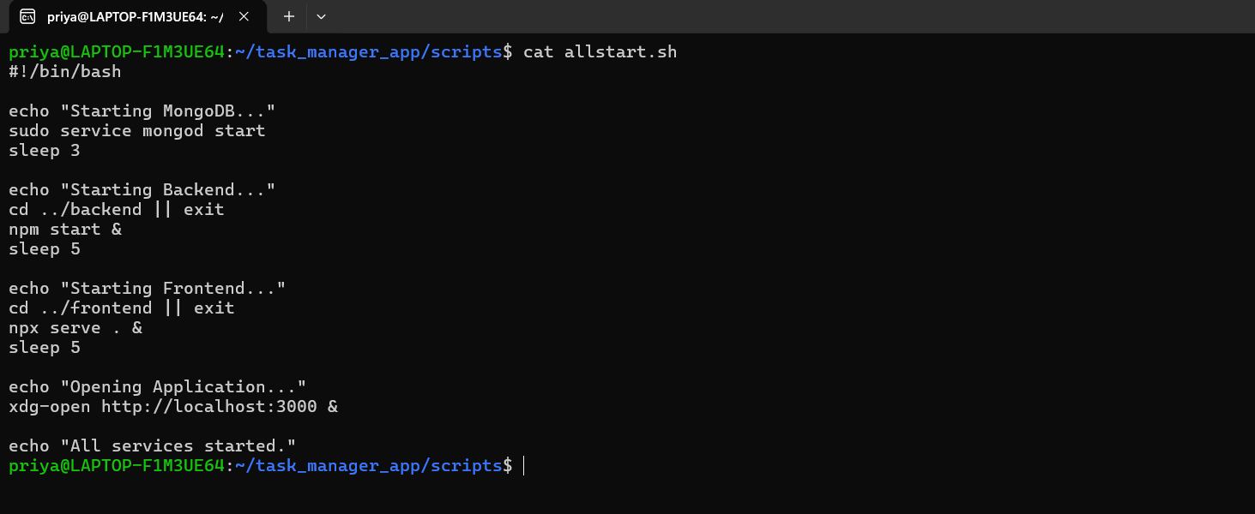
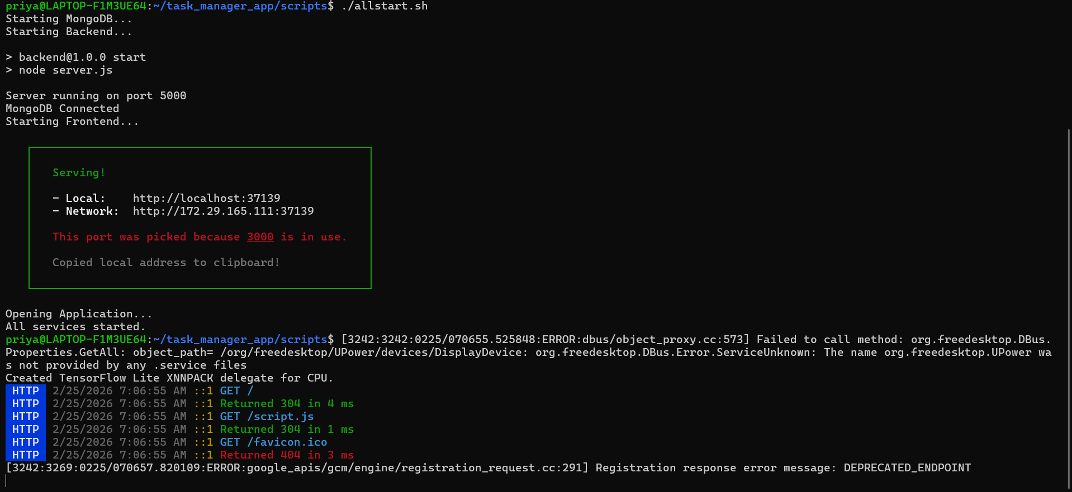
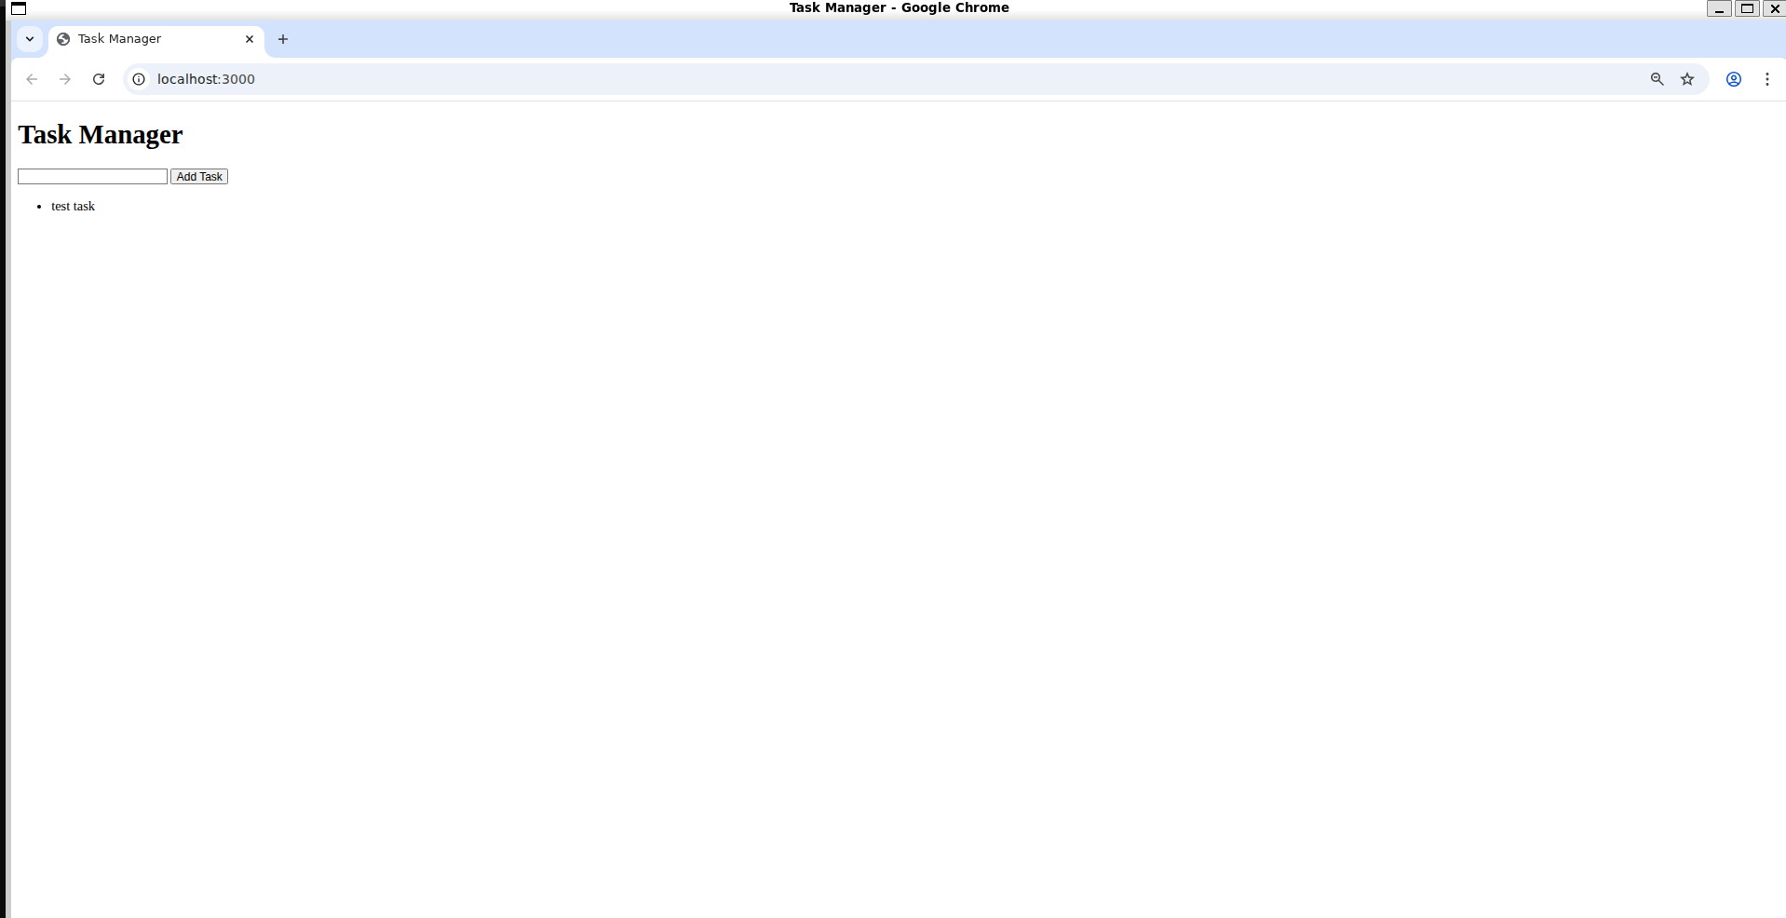

Part 2: Initialize Git
1. Initialize a Git repository in your local project folder

1. Initialize a Git repository in your local project folder.
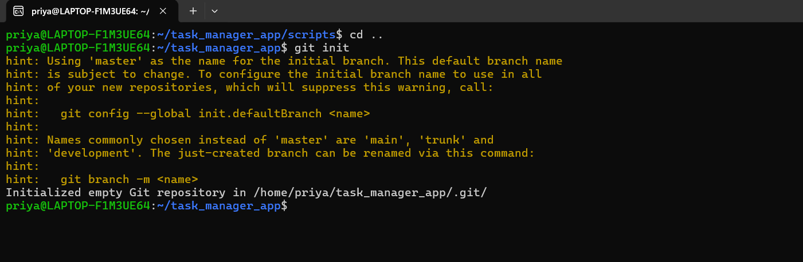
2. Add all files and create the first commit.
- git init → create local repo
- git add → stage files
- git commit → snapshot
- git remote add → connect remote
- git push → upload
as we already commits it shows nothing to commit.so directly we can push the code to remote once we made connection to the remote repository which we created in gitlab.
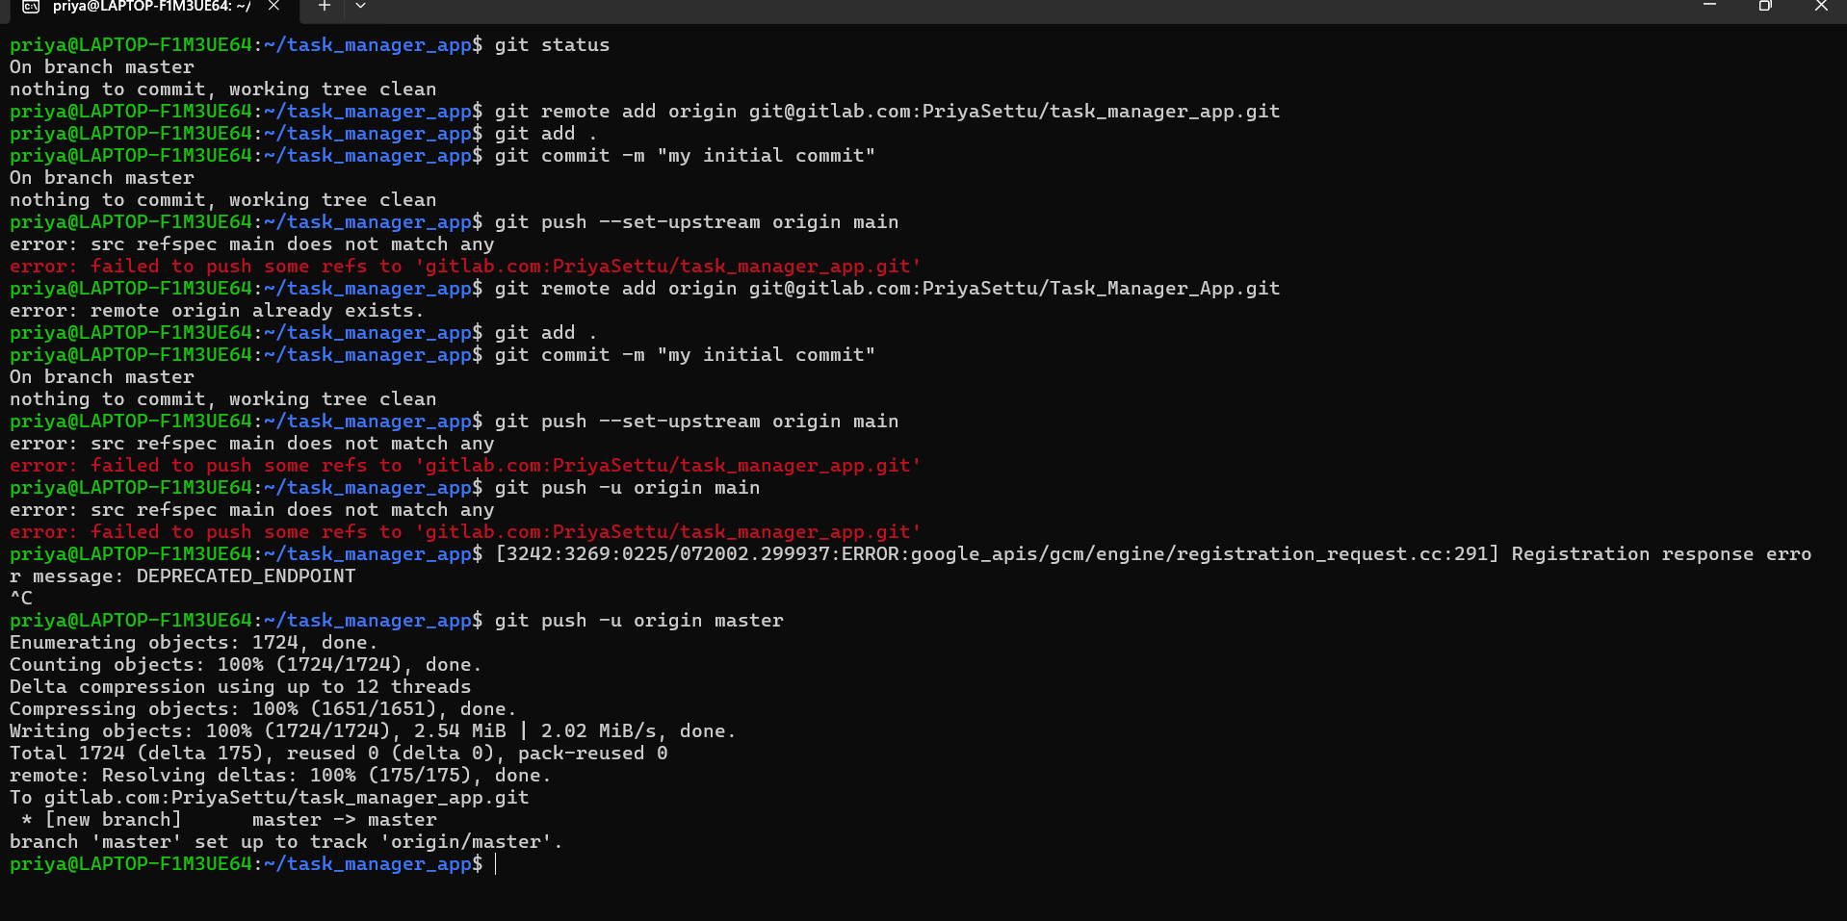
3. Create a new GitLab repository and push your local repository to it.
Go to:
👉 https://gitlab.com
Login
Click New Project
Choose Create blank project
Give Name
Do NOT initialize with README (important).-->as it will be considered as a first commit.
Click Create.

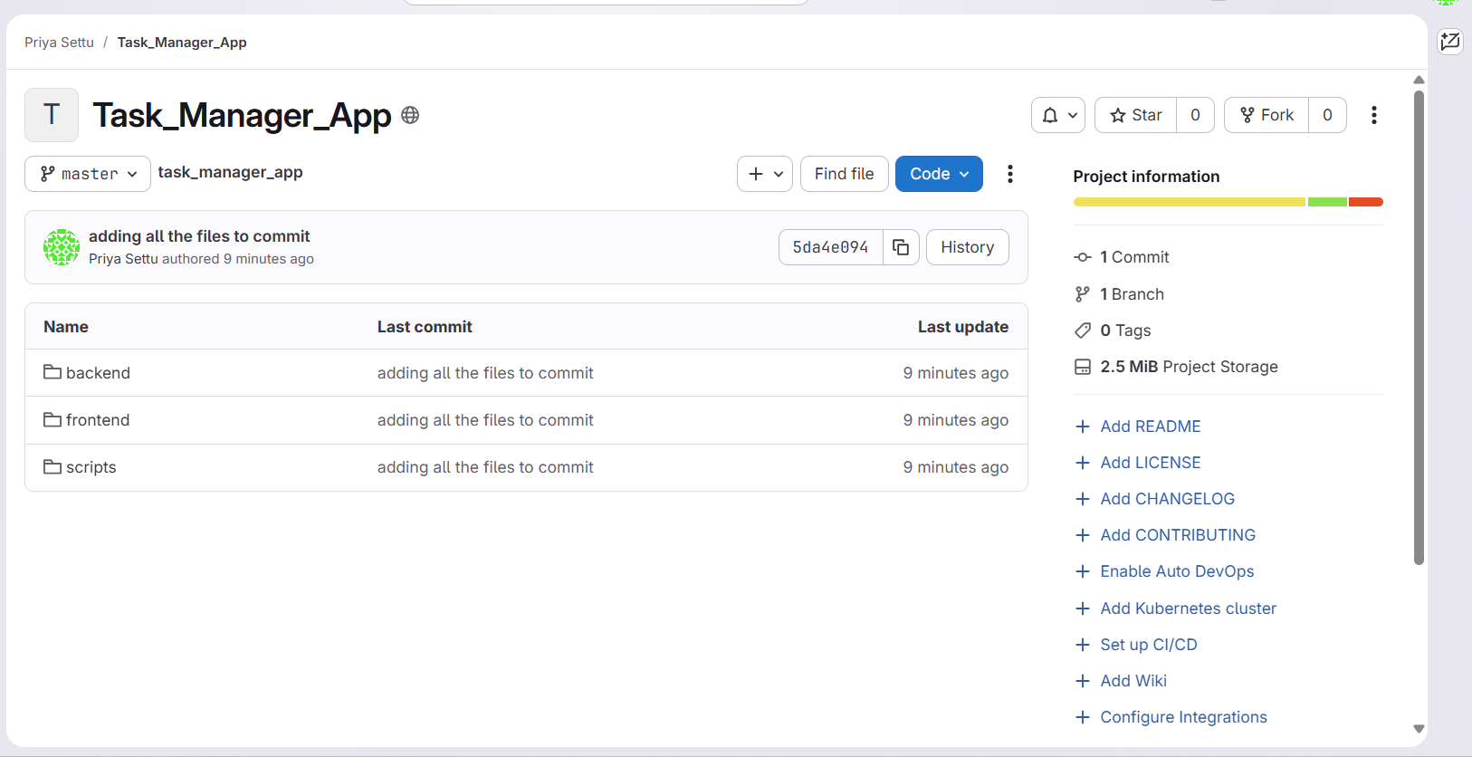
Part 3: Deploy in WSL 1. Clone the repository inside your WSL environment. 2. Install the required dependencies for backend and frontend. 3. Start the application components from WSL.--> already completed.
Part 4: Create a Service Monitoring Shell Script 1. Write a shell script that checks if the frontend, backend, and database services are running. 2. The script should output a simple status report. 3. Add the script to the repository and commit it to the main branchAlready completed

Part 5: Create a Feature Branch
- Create branch
- Make changes
- Commit
- Push feature branch
- Create Merge Request
- Review
- Merge into master
Master should stay stable.
1. Create a new branch from main.
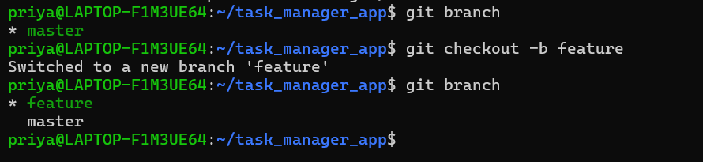
2. Make a small change in the frontend, such as updating a header or text.
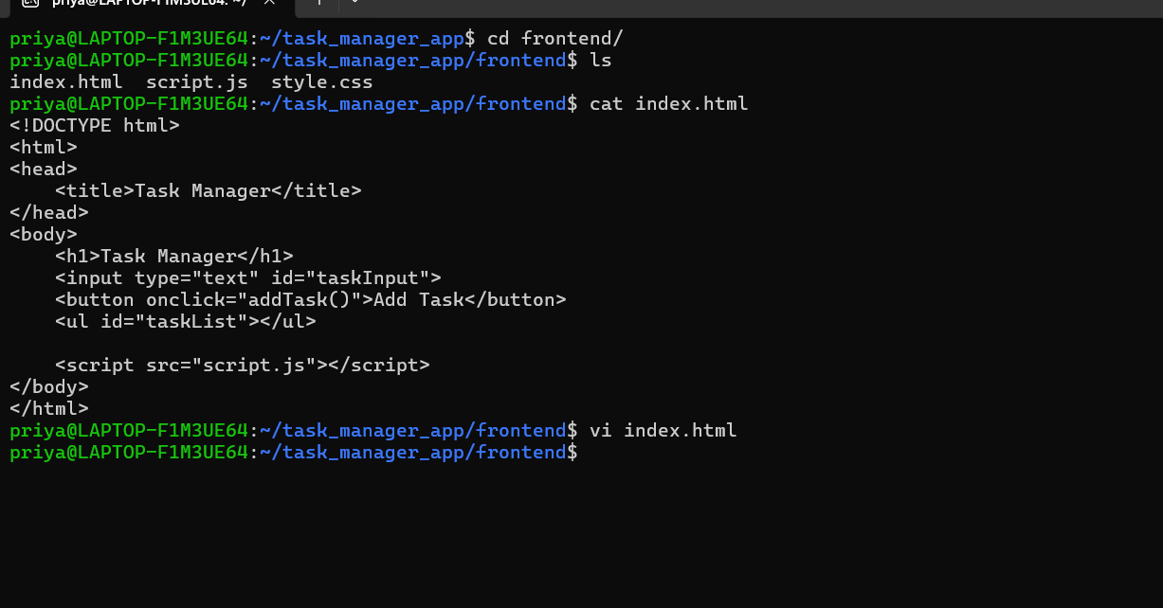
3. Commit and push this change to the new branch.
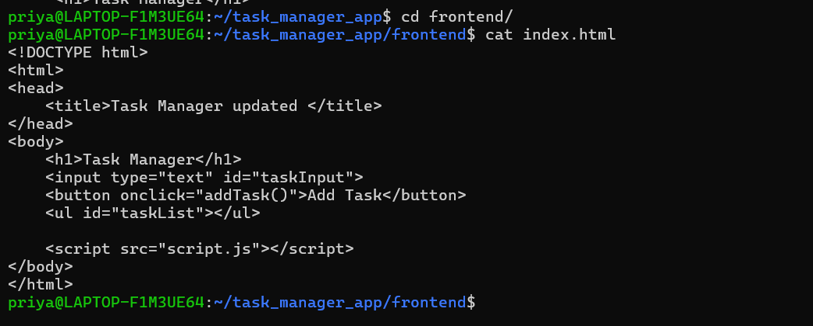
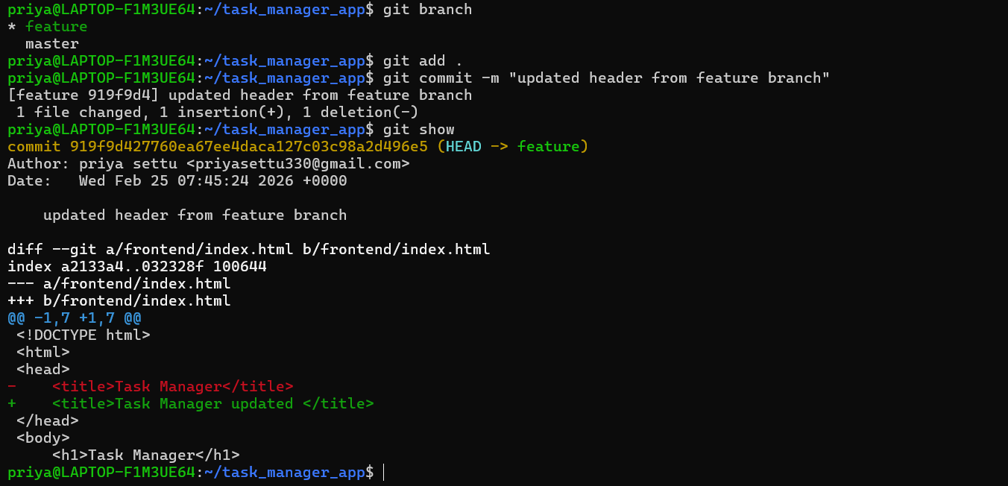
Now merged it locally.
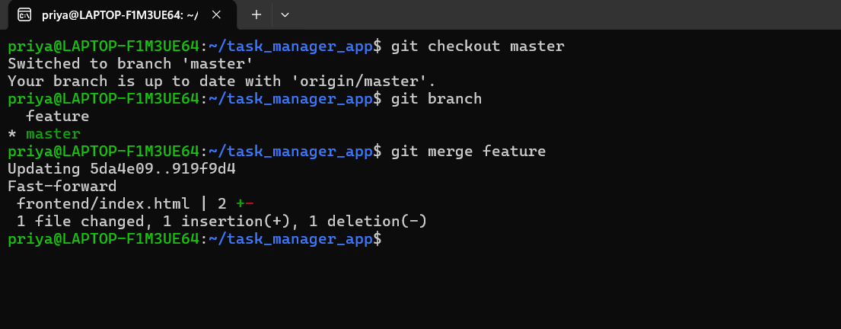
Now created merge request in gitlab:
git push -u origin feature
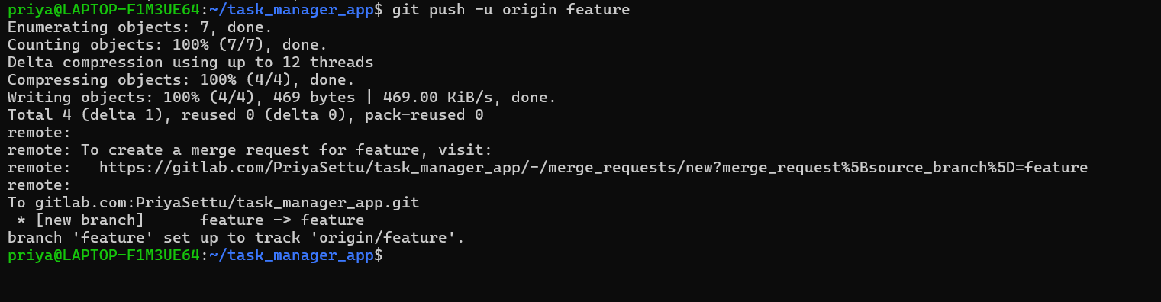
I just compared what are the changed are done in this application.
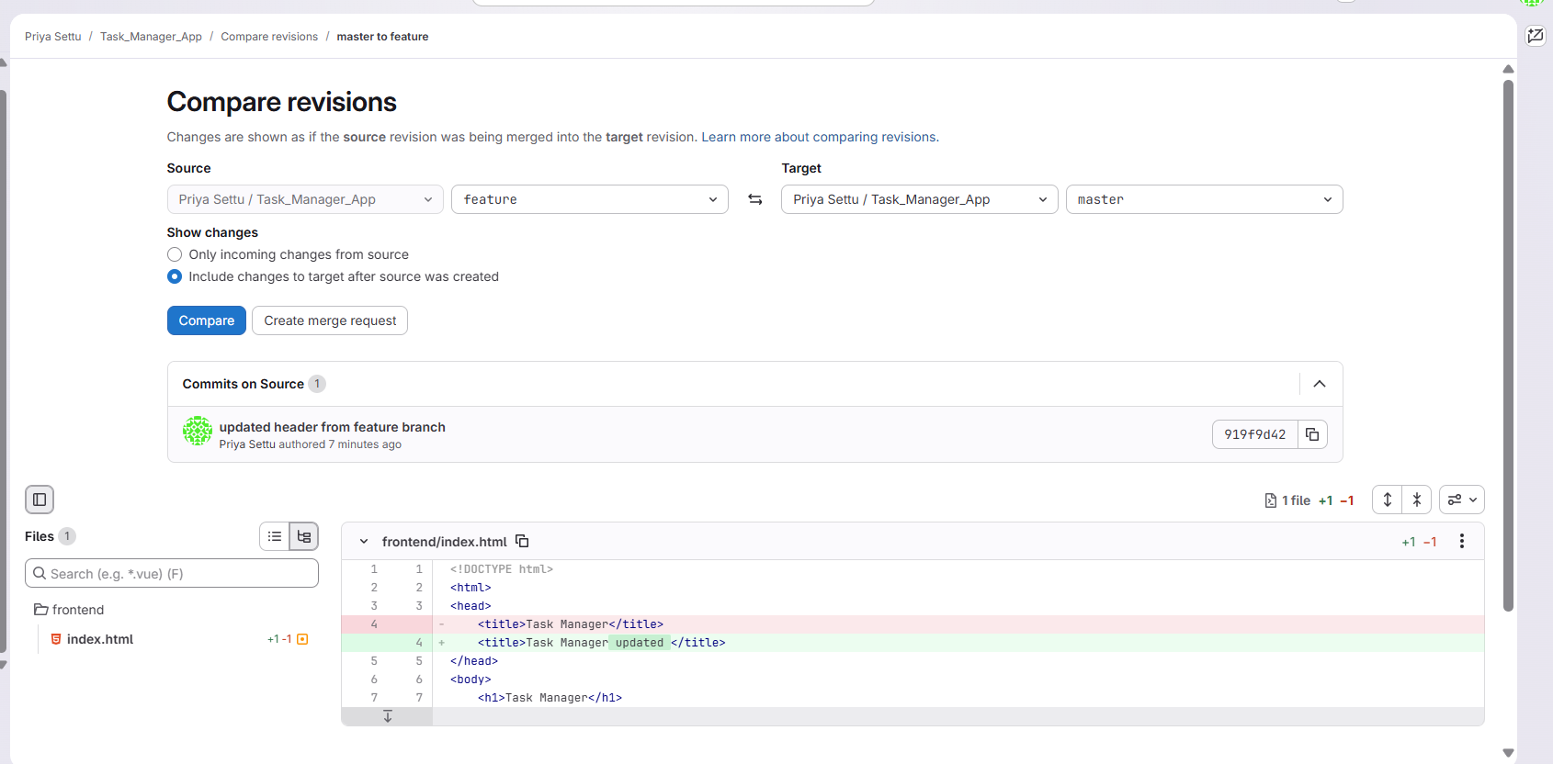
Now created merge request to master from gitlab
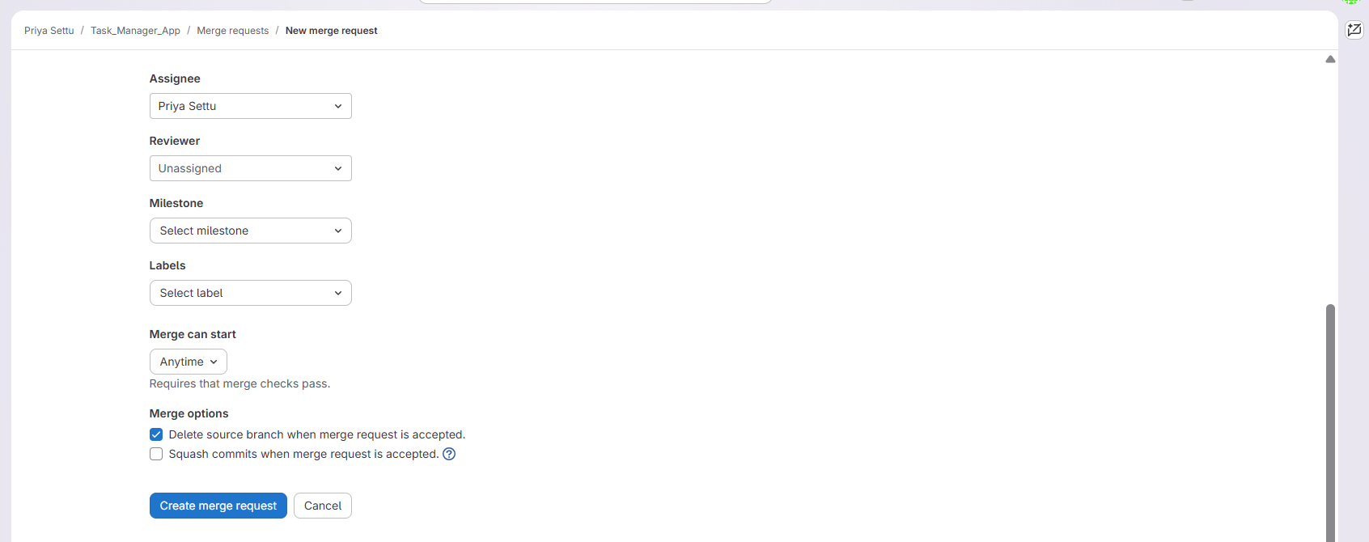
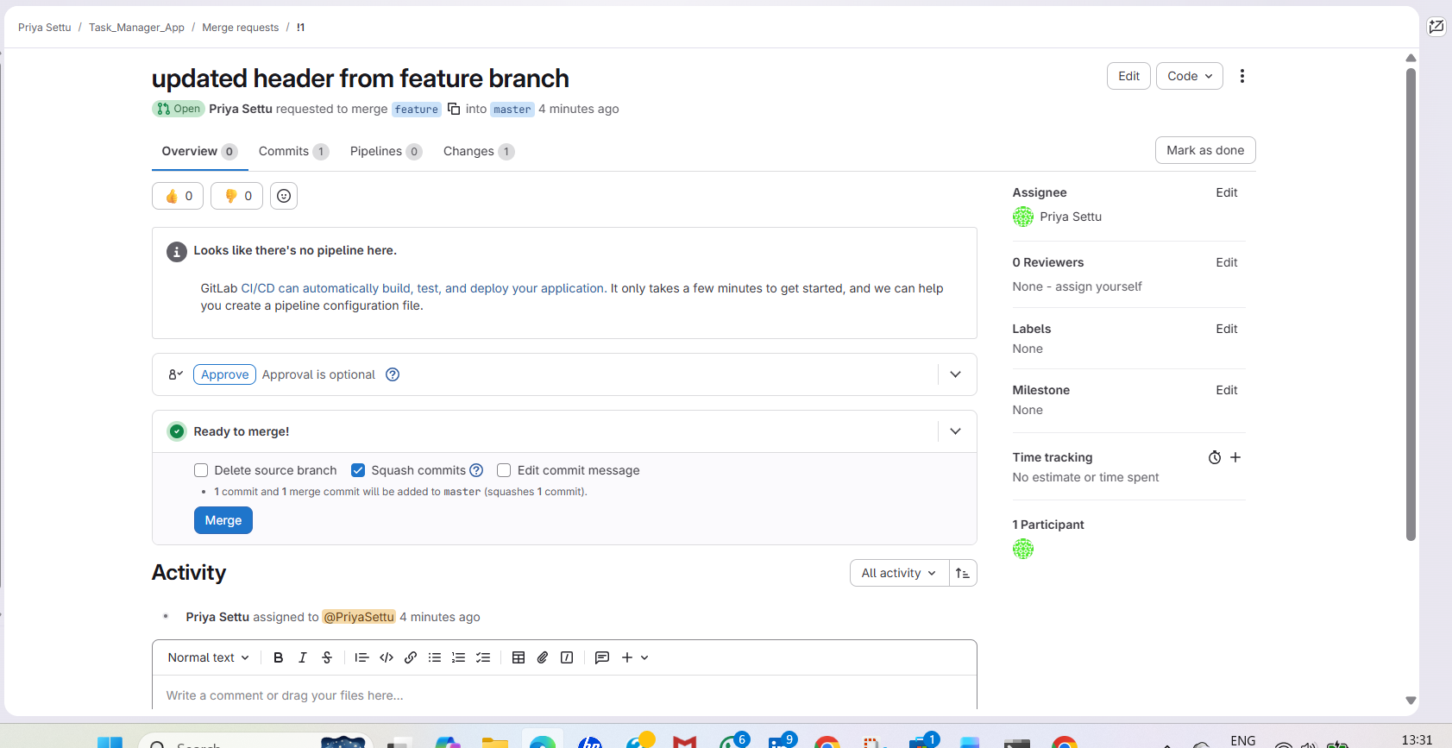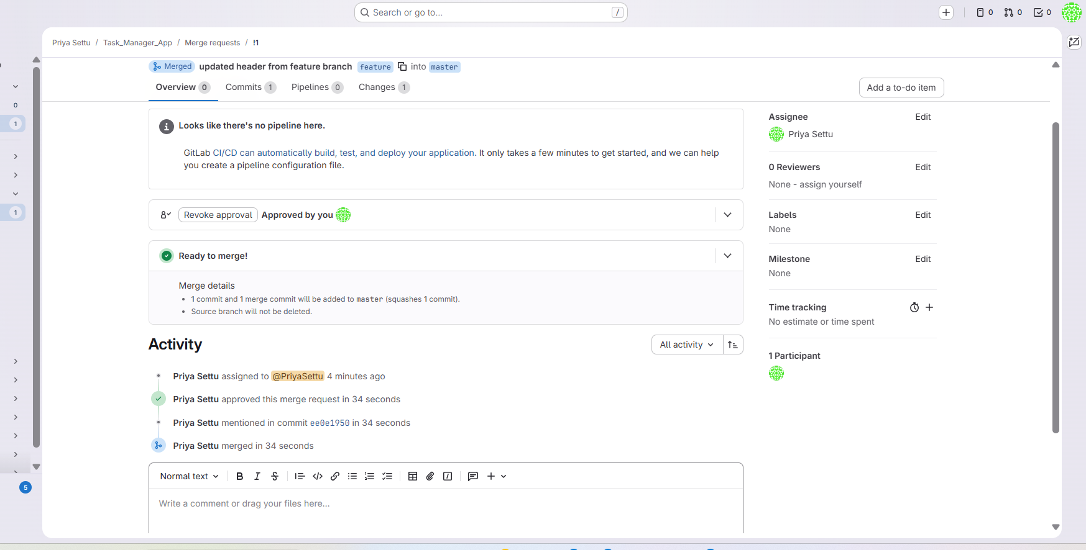
Deploy UI Change in WSL
- Switch to the feature branch inside WSL.
Pkill node to terminate all the services
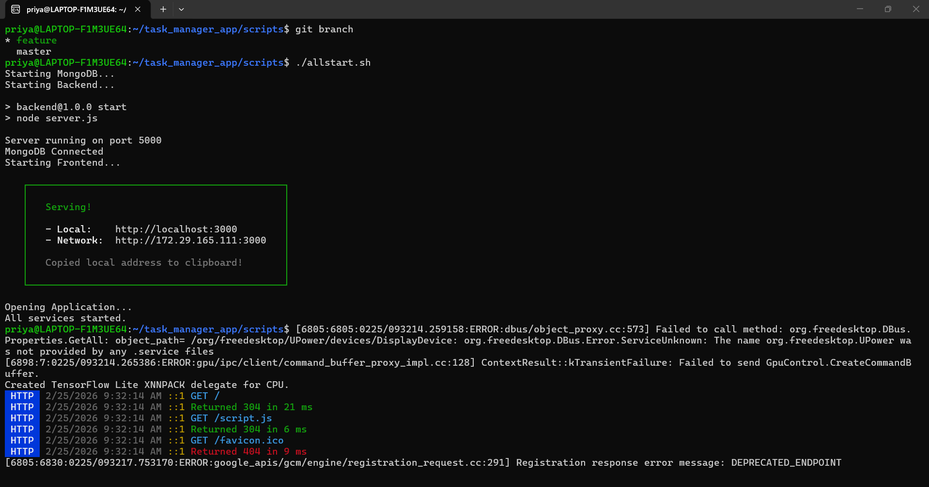
- Run the updated application with the UI modification applied
The page has been deployed with title updated.
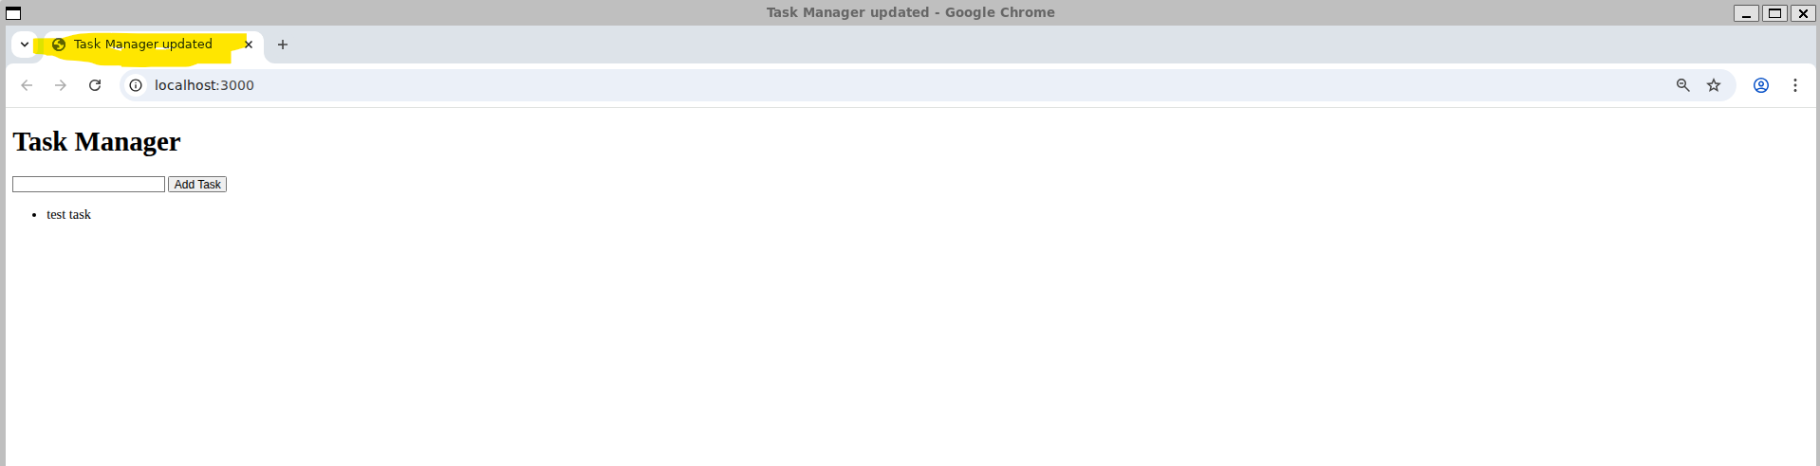

Pull the updated main branch into your WSL environment and redeploy.
